**DEPLOYMENT USING RENDER**

Make sure you have the following line of script/code in your express.js file

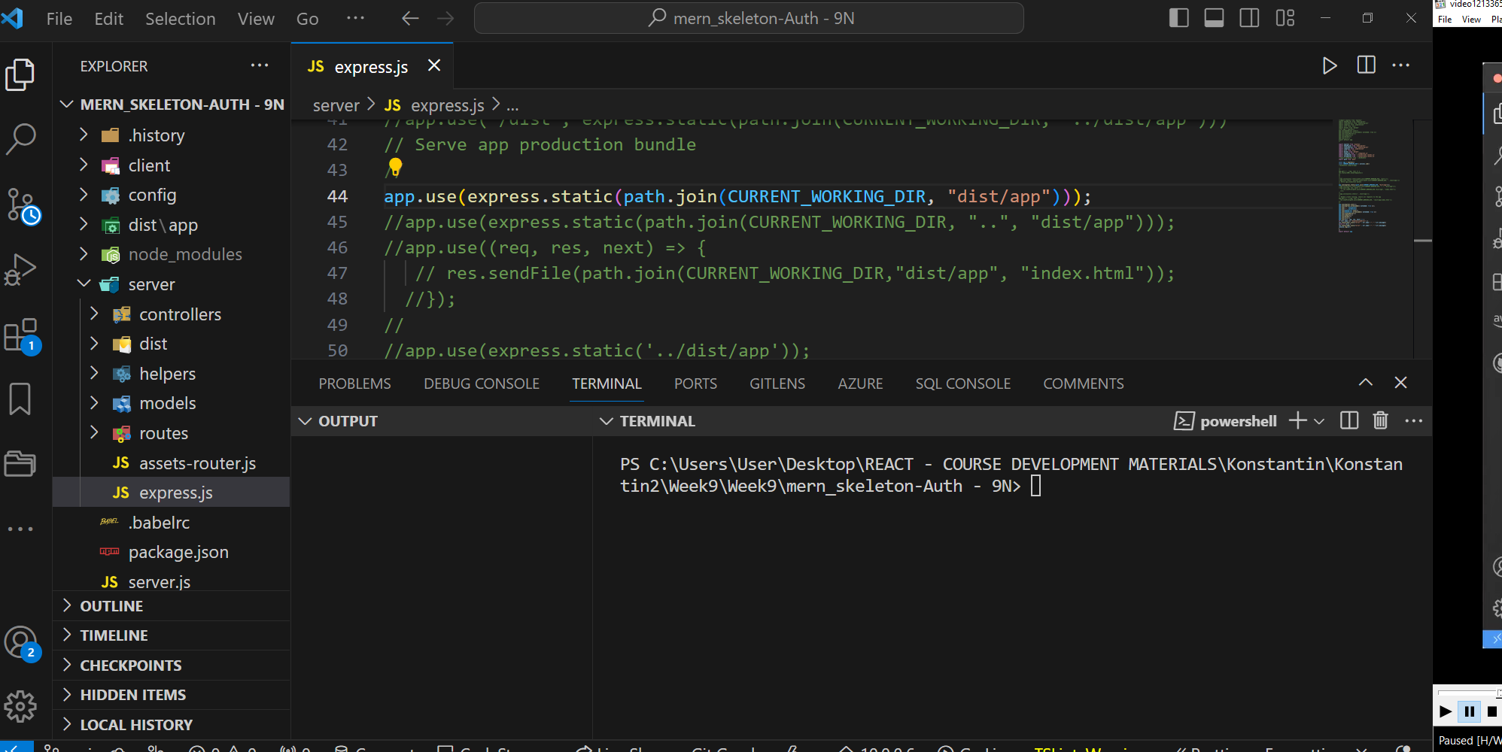

In the client open the vite.config.js make sure you have this build replace it with any existing one

build: {

    outDir: '../dist/app',

  },

Update the script in client/index.html as follows:

<!DOCTYPE html>

<html lang="en">

<head>

<meta charset="UTF-8" />

<link rel="icon" type="image/svg+xml" href="/favicon.svg" />

<meta name="viewport" content="width=device-width, initial-scale=1.0" />

<title>Vite App</title>

</head>

<body>

<div id="root">Welcome to Frontend

</div>

    <script type="module" src="/src/main.jsx"></script>

</body>

</html>

Cd client run yarn build

You should see a dist folder on the same level as the client

Open a new terminal and run the command node server

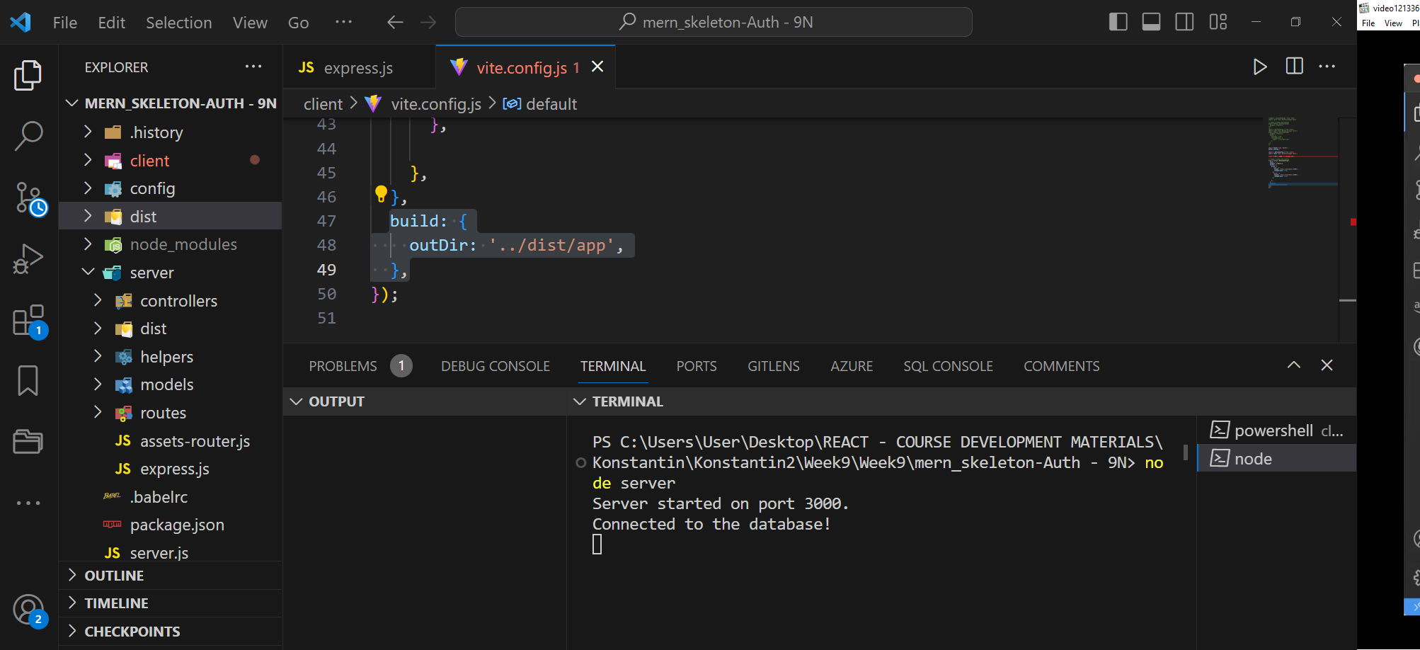

Go to localhost 3000 in your browser you should see the application running

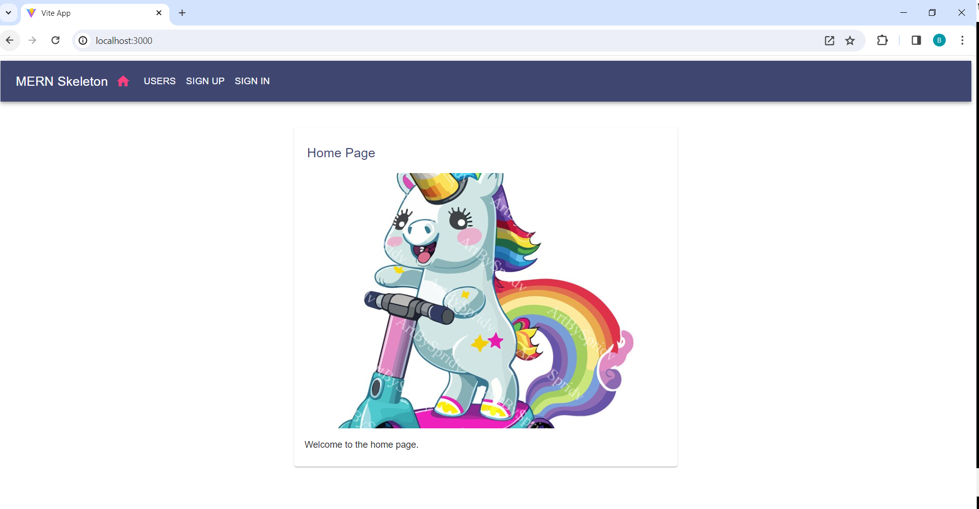

Create a .gitignore file both on the client and server and move unnecessary files e.g node_modules into it on the client and the server.

Create a repository in GitHub and push your code to GitHub do it at the root

Go to render, if you already have an account sign in if not signup then sign in

Click on New, click on Web Service

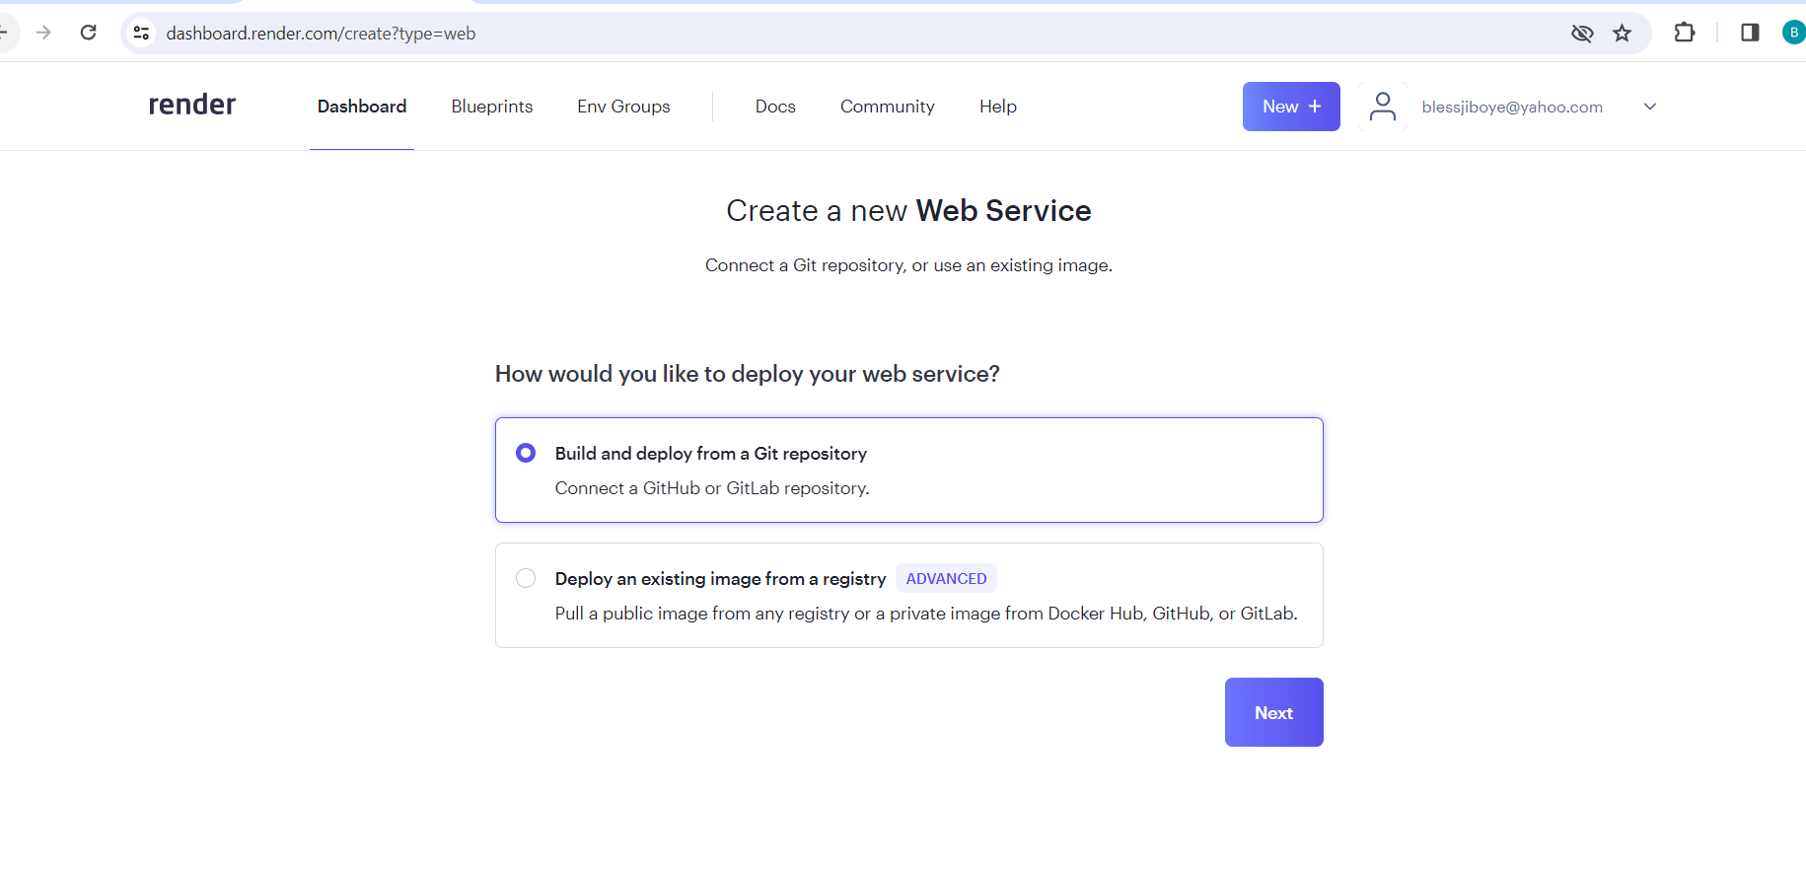

Click on Next

Connect to your GitHub repository where you pushed your code to.

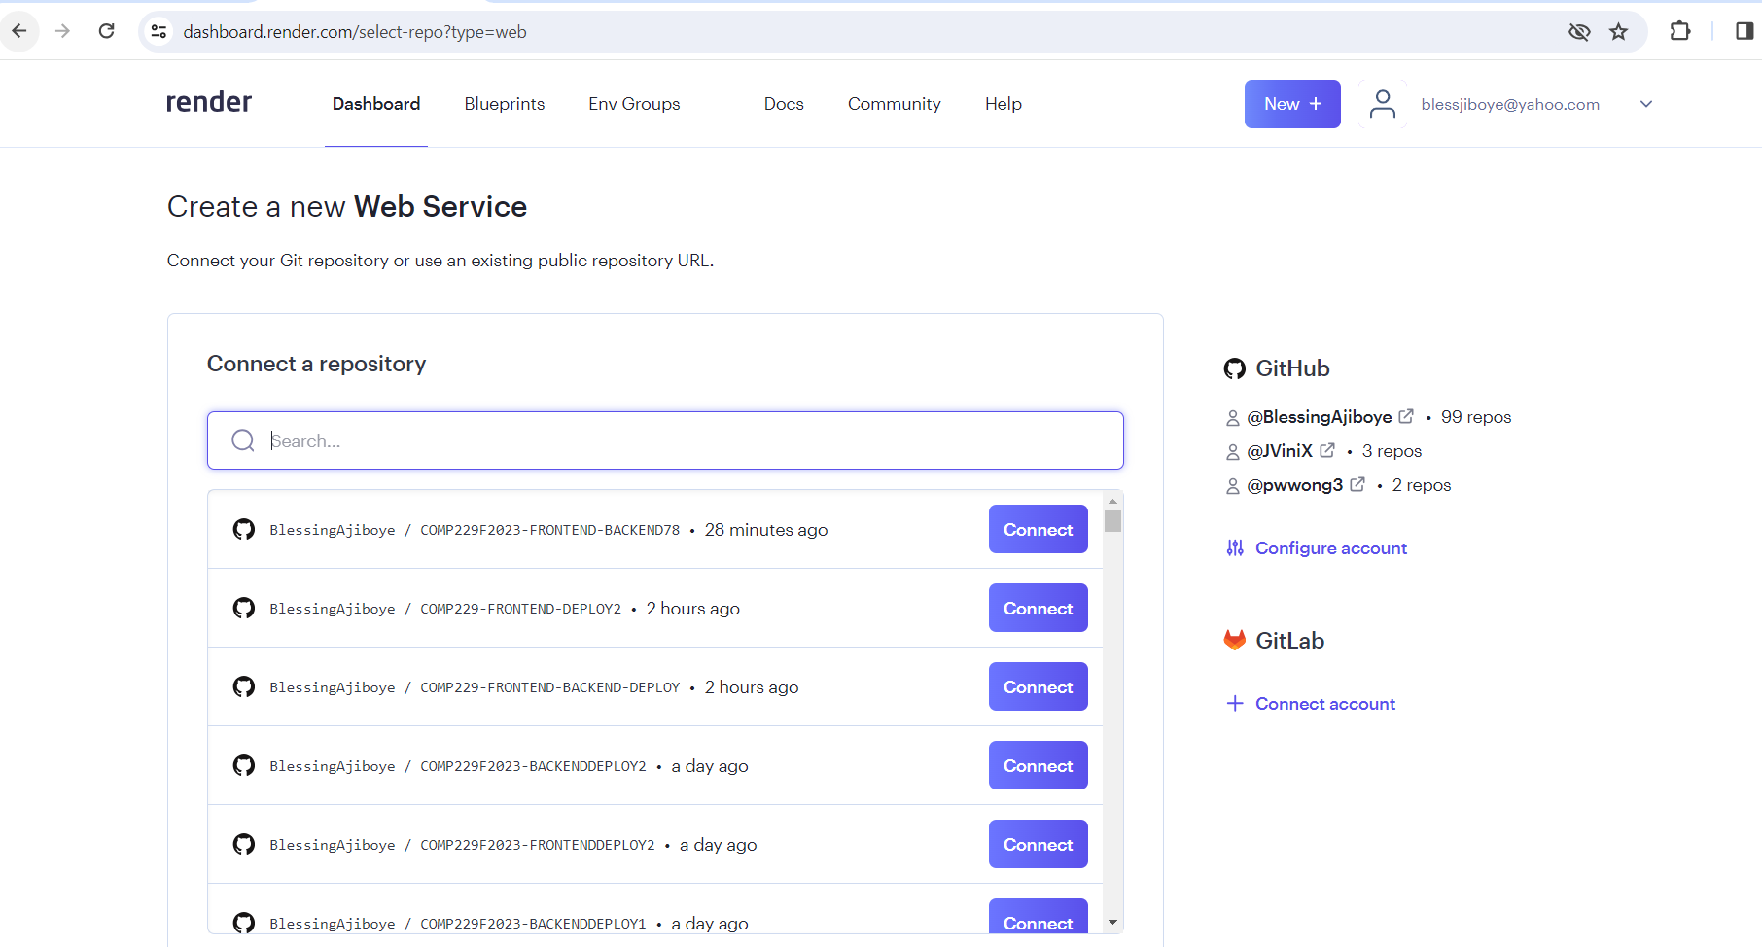

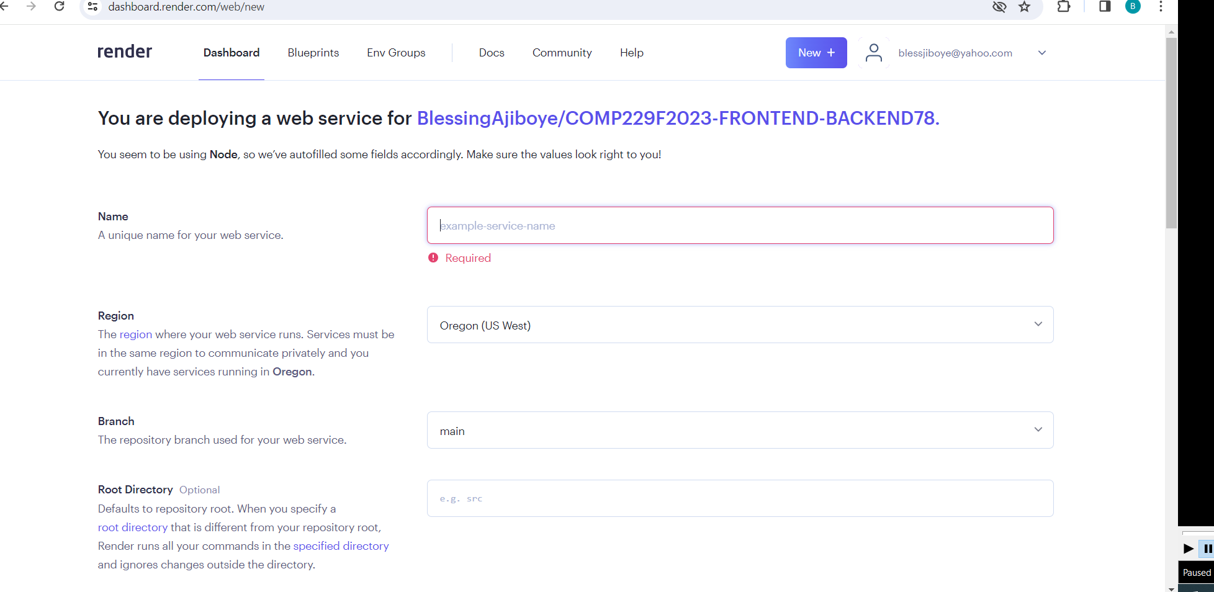

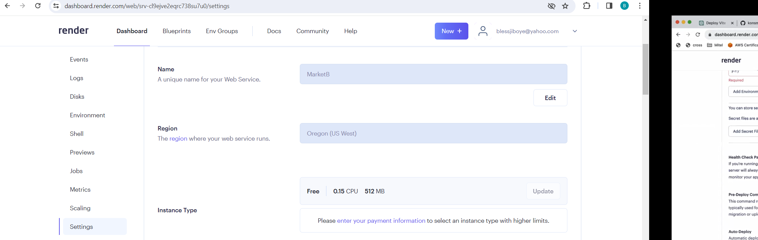

Give your App a name i.e MarketB

Leave the default region

Leave the Branch as main

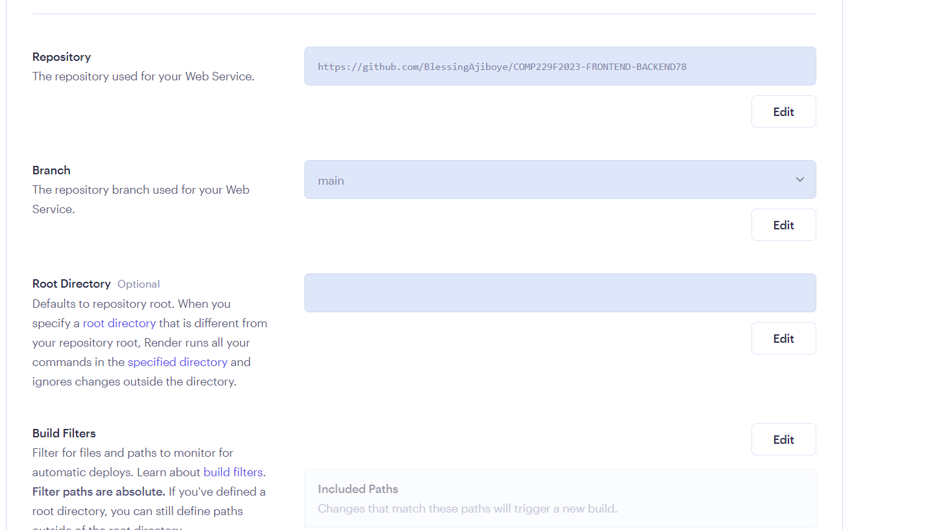

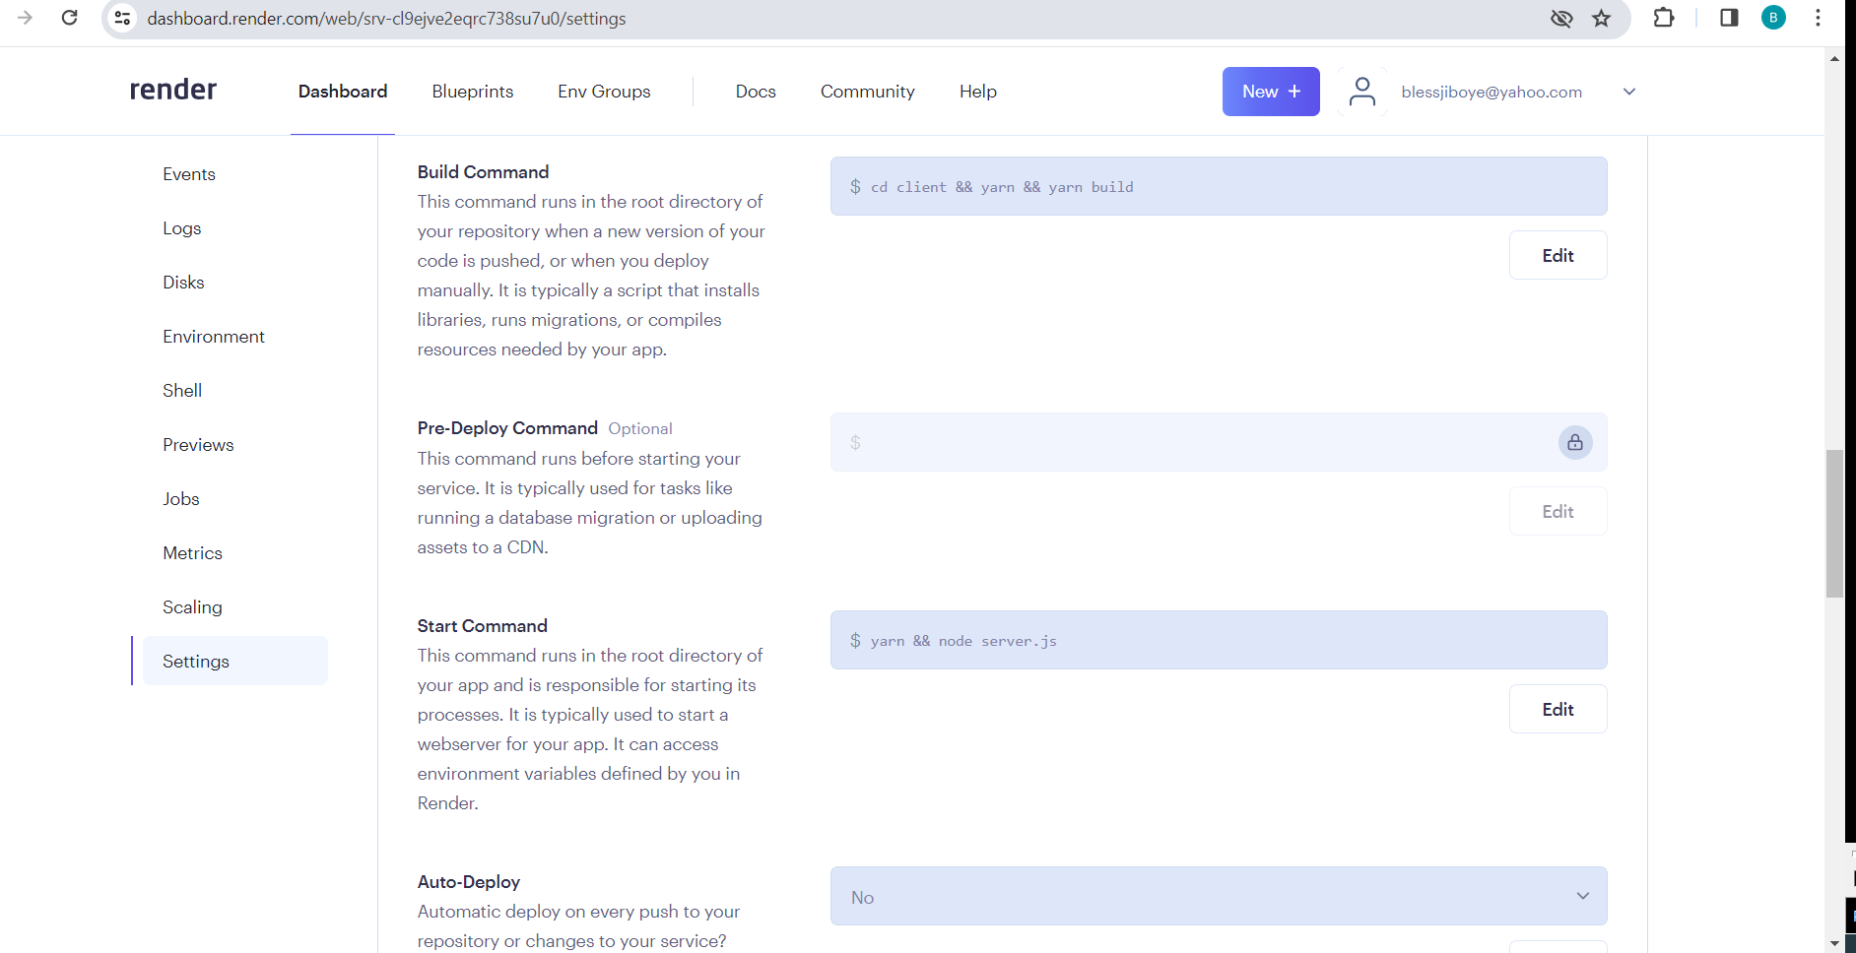

Set the Build Command as cd client && yarn && yarn build

Start command as yarn && node server.js

Set Auto Deploy to No

Click on Advanced

Click on Environment Variable

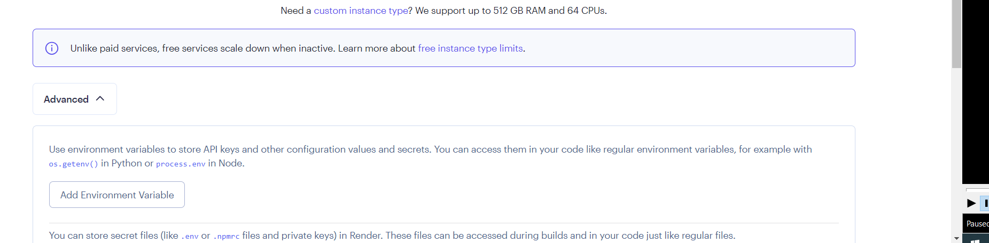

Set the NODE_VERSION to a value higher than 16 i.e 16.18.1

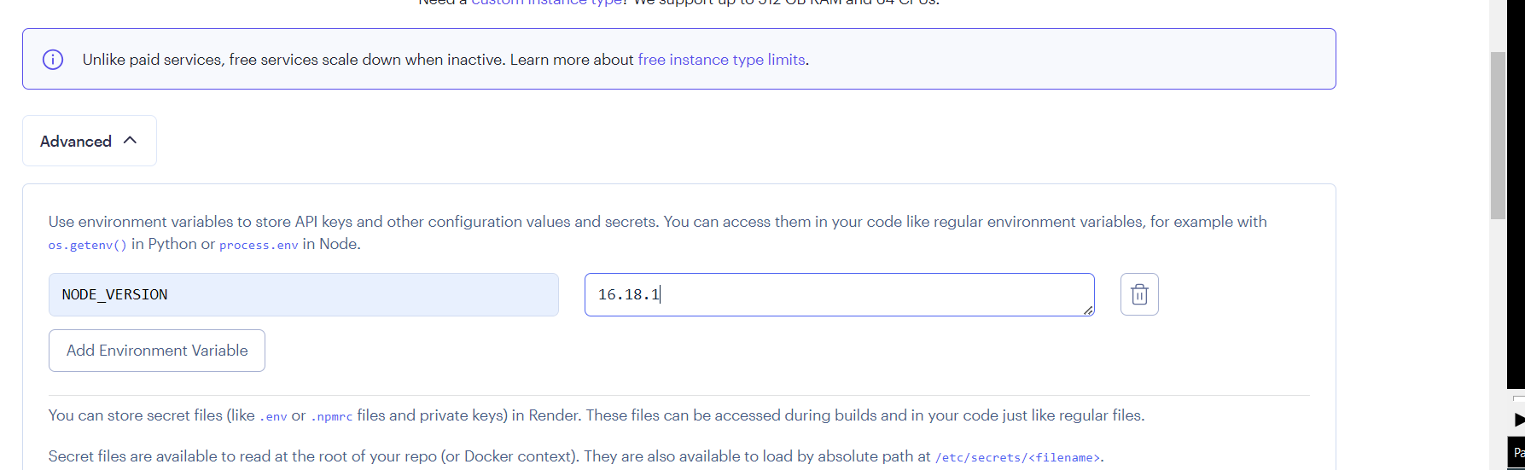

Click on Create Web Service

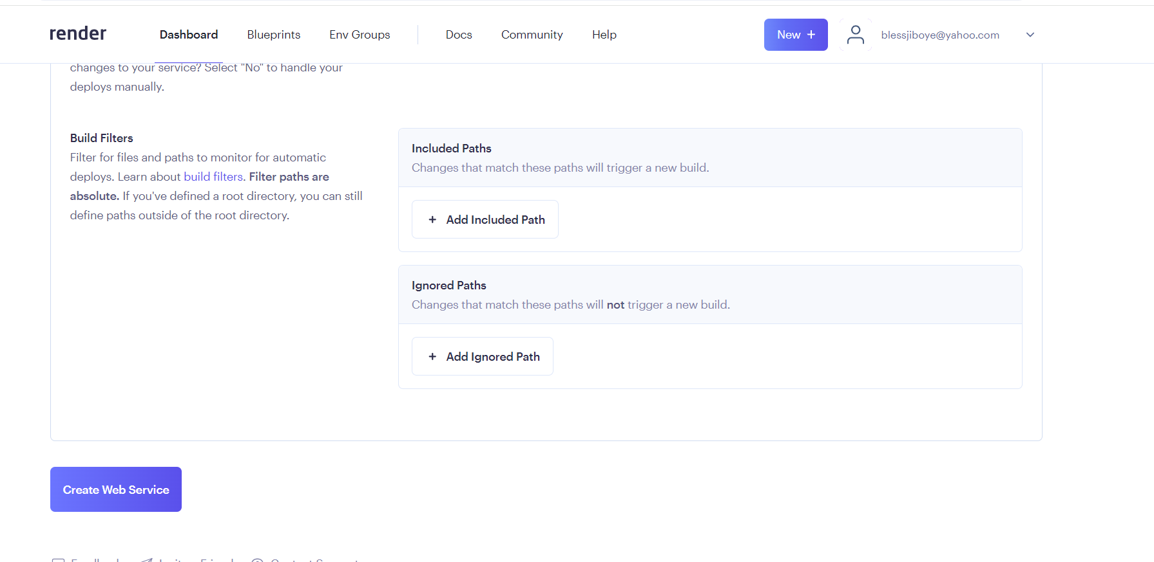

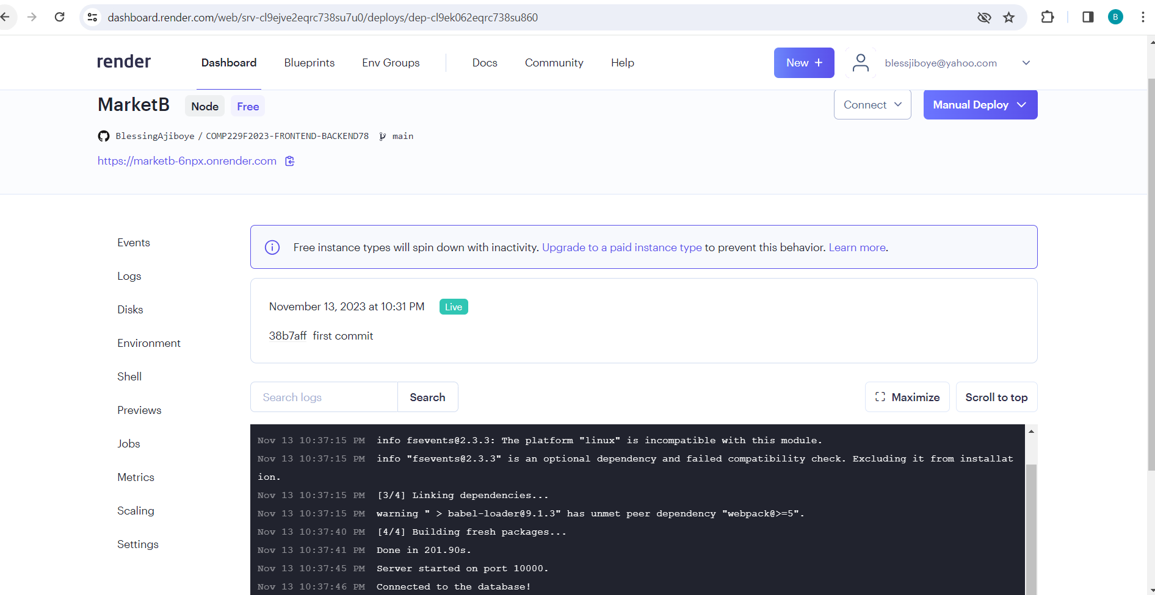

OR

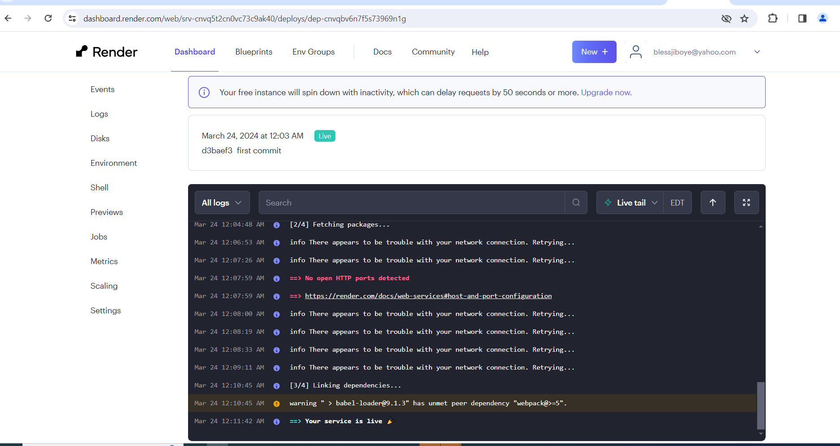

Open the render url in the browser window

https://marketb-6npx.onrender.com

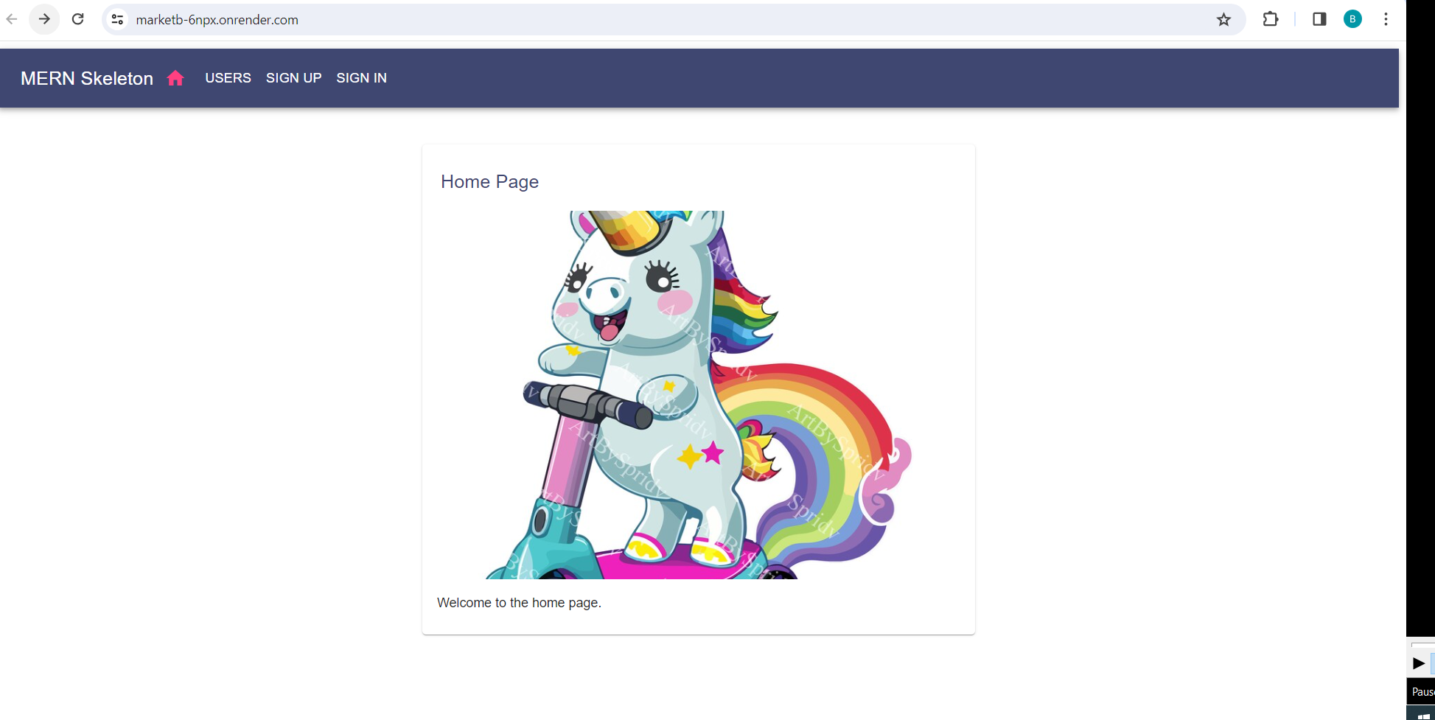

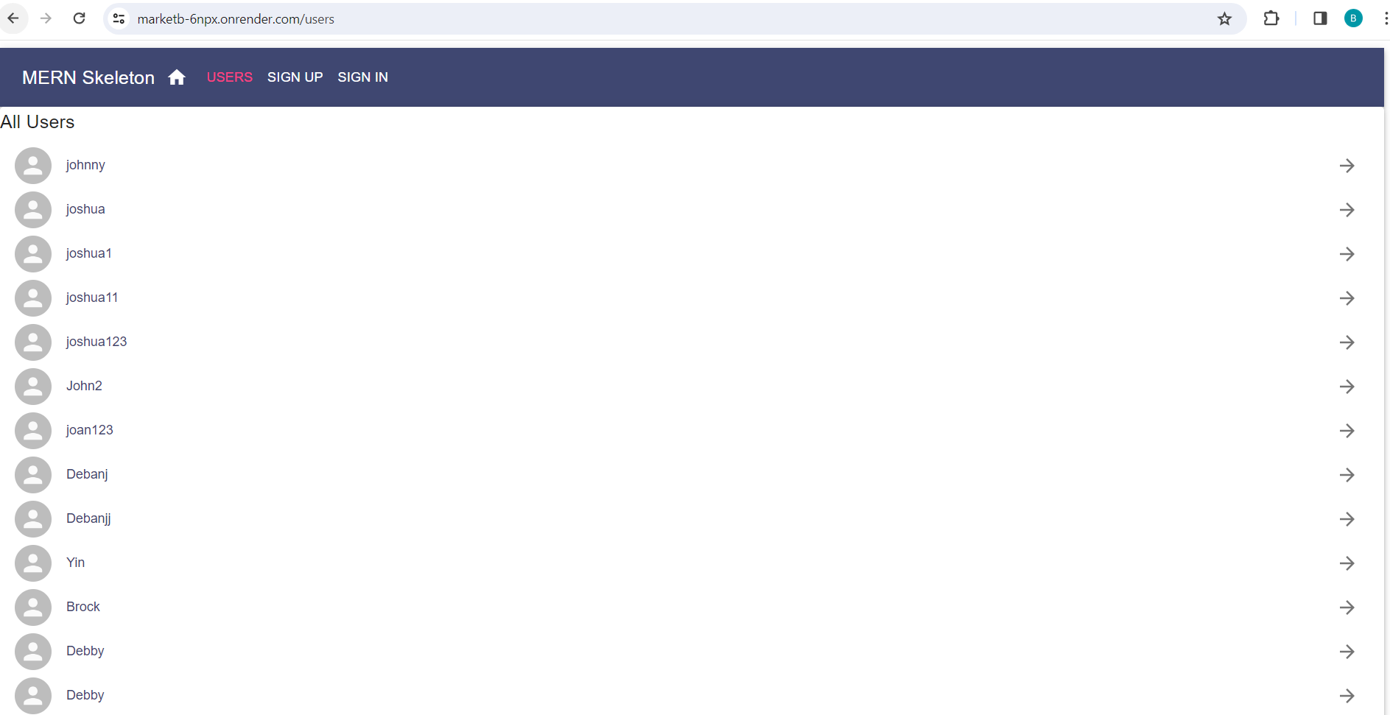

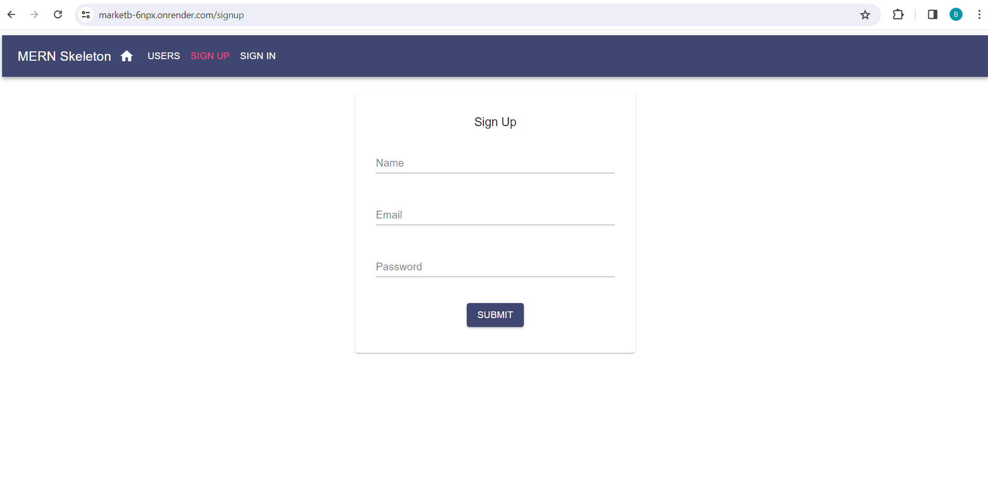

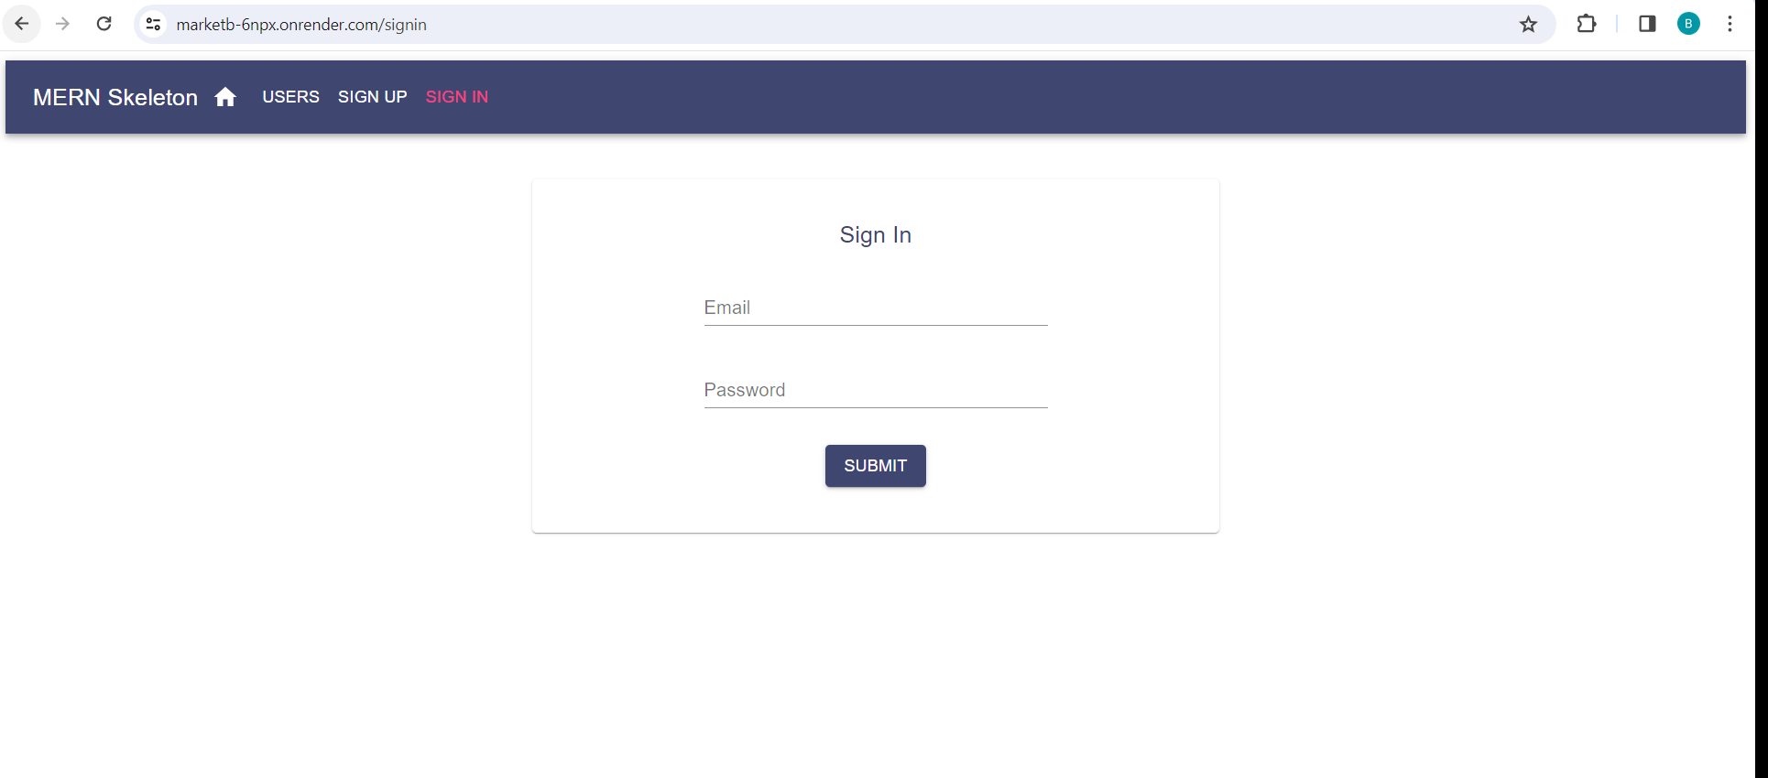

OR

Set the NODE_VERSION to a value higher than 16 i.e 21.1.0

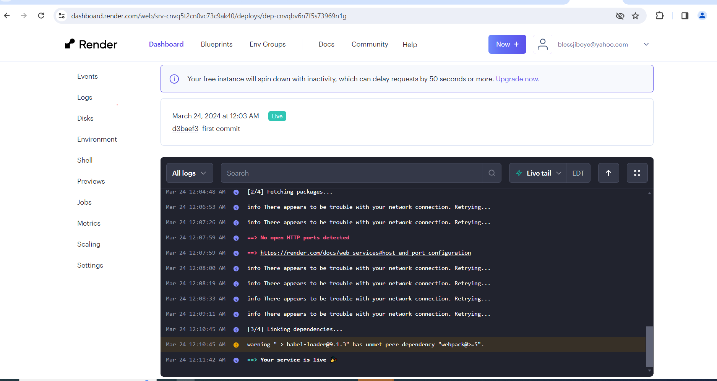

[https://blessstore.onrender.com](https://blessstore.onrender.com/)

